

| **TITLE**: Introduction and Implementation using SPARK AR |
| --- |

**AIM:**

1. Install the Spark AR
2. Design the social media filter (Sample example as follows)
   1. Tattoo
   2. Scars
   3. Avatar
   4. Hairdressing accessories
   5. Magical powers (Ex. Laser through eyes)
   6. Students choice
3. Demonstrate the filter through camera of mobile or laptop or system

**______________________________________________________________________**

**Expected OUTCOME of Experiment:**

Will gain hands-on experience in creating interactive AR filters using SPARK AR Studio, fostering creativity and technical skills while understanding the potential of augmented reality in social media.

**_____________________________________________________________________**

**Books/ Journals/ Websites referred:**

<https://www.youtube.com/watch?v=2ypJ9CFOK5U&list=PLTgRMOcmRb3Nx2LF5EHU4MtmpAQBafVgE&index=1&ab_channel=Packt>

**_____________________________________________________________________**

**Hardware or software component minimum requirement**

**Operating system: Windows 10 (64 bit) or MacOS 10.14+**

**RAM: 4 GB**

**CPU (if Intel): Intel Core i3 2.5Ghz, or AMD Bulldozer/Jaguar/Puma/Zen with SSE4.1 instruction set. Processors produced in the last decade will likely support this instruction set.**

**CPU (if Apple Silicon ARM64): M1 or newer.**

**GPU: Intel HD Graphics 4000/Nvidia GeForce 710/AMD Radeon HD 6450. Must support OpenGL 3.1.**

**Monitor resolution: 1280 x 768**

**Steps to execute:**

**1. Install Spark AR Studio: Download and install Spark AR Studio from the official website. Open the software and create a new project.**

**2. Import Assets: Import any images, 3D objects, textures, or audio files that you want to include in your filter. You can use built-in Spark AR assets or custom elements.**

**3. Add a Face Tracker: In the Scene panel, add a "Face Tracker" object. This will track the user's face and allow the filter elements to follow facial movements.**

**4. Create a Face Mesh: Under the Face Tracker, add a "Face Mesh" object. This mesh will be used to apply textures or effects directly to the user's face.**

**5. Apply Materials and Textures: Create a new material for the Face Mesh. Customize the material's properties and apply textures or images to create effects like makeup, masks, or skin enhancements.**

**6. Add 3D Elements: If your filter includes 3D objects (like glasses or hats), add them to the Face Tracker in the Scene panel. Position and scale them to fit the face properly.**

**7. Use Patch Editor: Open the Patch Editor to add interactivity and animations to your filter. Use logic blocks to trigger effects based on user interactions, like tapping or facial expressions.**

**8. Preview the Filter: Test your filter using Spark AR Studio's built-in simulator or connect your smartphone to see how it looks in real-time on a device.**

**9. Export and Publish: Once you’re satisfied with the filter, export it from Spark AR Studio. Submit it for review on the Spark AR Hub to publish it on platforms like Instagram or Facebook.**

**Drive or GitHub link:**

[**https://drive.google.com/drive/folders/1ibKP6w3kUVQxWtNpDxaw8xgNXLsmhi1T?usp=drive_link**](https://drive.google.com/drive/folders/1ibKP6w3kUVQxWtNpDxaw8xgNXLsmhi1T?usp=drive_link)

**Output(s) (Screen Shots):**

**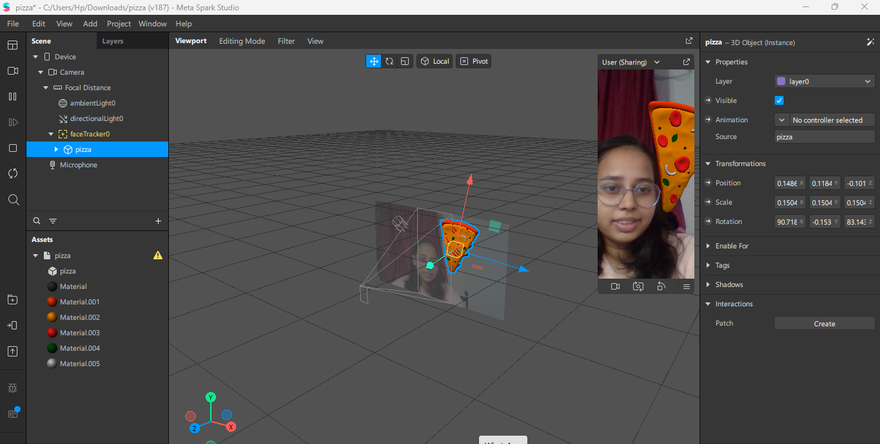  
  
  
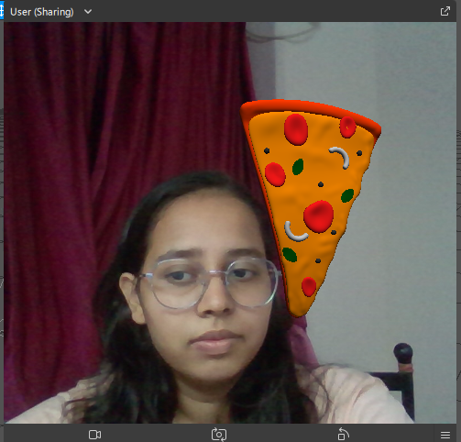**

**Conclusion and discussion:**

**In conclusion, creating a filter using Spark AR Studio provides a powerful yet accessible way to develop engaging augmented reality experiences for social media platforms. The step-by-step process, from importing assets to using the Patch Editor for interactivity, highlights the platform's flexibility and creative potential. Through this experiment, we observed the ease with which interactive and dynamic filters can be crafted, optimized, and deployed. Spark AR Studio's user-friendly interface and robust capabilities make it an ideal tool for both beginners and experienced creators to bring their AR visions to life.**

**Date: 12/10/24 Signature of faculty in-charge**